**Feedback Control Systems**

**Lab Report 7**

**Hafiz Ahmad**

**19l-1316**

**Section-6B2**

**Modeling and System Identification of a DC Motor**

**INTRODUCTION:**

An essential step in the analysis and design of control systems is modeling the system's dynamical characteristics. You will investigate the steady-state and dynamic properties of a DC motor in this experiment. A first-order linear system is created by combining a motor and generator in this case. Because it is possible to model many real-world systems in this way, it is important from a practical standpoint. This experiment's DC motor is just one example of this. The open-loop response of the DC motor is described by the electrical equations Vm(t) RmIm(t) Eemf(t) = 0 and Eemf(t) = Kmm(t). The motor's torque is described by the mechanical equations Tm(t) = Jeq [d dt m(t)] and Tm(t) = Kt Im(t). where Table 7.1 provides descriptions of Tm, Jeq, m, Kt, Km, and Im. Friction and damping are not taken into account by this model. Equations can be used to derive the DC motor's mathematical model, G(s). The angular speed of the DC motor in relation to the input voltage Vm is represented by the following first-order transfer function, G(s). 𝐺(𝑠) = 𝜔𝑚(𝑠)/𝑉𝑚(𝑠) = 𝐾/𝜏𝑠+1. Where 𝜏 is the time consistent of the framework, and 𝐾 is the consistent state gain (otherwise called DC gain). The first order system is defined by these two parameters. A straightforward test based on a stable system's step response is the bump test. The system receives a step input and records its response. Consider the system that is provided by the following transfer function as an illustration: 𝑌(𝑠)/𝑈(𝑠) = 𝐾/𝜏𝑠+1. The transfer function Y(s) U(s) is used to generate the step response depicted in Figure. At time t0, the step input begins. The output signal is initially at y0, with the minimum and maximum values of the input signal, umin and umax, respectively. From the output and input signals, steady-state gain is K = y/u, where y = yss y0 and u = umax umin. To determine the model time constant, we first need to determine where the output is supposed to be at the time constant form: 𝑦(𝑡1 ) = 0.632𝑦𝑠𝑠 + 𝑦0. The time t1 that corresponds to y(t1) can then be read from the response data in Figure a. As can be seen, the time t1 is equal to: The following formula can be used to calculate the model time constant: 𝜏 = 𝑡1 − 𝑡0. Using NI LabVIEW and the NI ELVIS platform, the DC Motor Control Trainer demonstrates the fundamentals of DC motor controls. The purpose of the experiment is to demonstrate how to take voltage and speed measurements of the responses using the virtual interface. The trainer's components are identified by their ID numbers.

**OBJECTIVES:**

* Study the characteristics of step response of first order servo system
* Measure the steady state gain  and time constant 
* Familiarize with QNET DC motor trainer

**Procedure:**

1 Start by opening QNET_DCMCT_Modeling.vi.

2 Make sure you choose the right device.

3. Execute the QNET_DCMCT_Modeling.vi file. The DC motor ought to start turning.

4 Select: in the Signal Generator section.

After collecting a step response, click the Stop Button to stop the VI from running. Amplitude = 2.0 V Frequency = 0.40 Hz Offset = 3.0 V 5

6 To view the measured response, select the Measurement Graphs tab.

7 Compute the steady-state gain of the DC motor using the responses in the speed (rad/s) and voltage (V) graphs and fill in the values in table 7.5. For more information on how to locate the steady-state gain from a step response, see the Bump test Method section. Finally, you can measure data with the Cursor Palette and zoom functions with the Graph Palette.

|  |  |  |  |  |
| --- | --- | --- | --- | --- |
| |  | | --- | | **Description** | | **Symbol** | **Value** | **Unit** |
| **Steady-state motor speed** | 𝜔𝑠𝑠 | 150 | 𝑟𝑎𝑑/𝑠 |
| **Initial step motor speed** | 𝜔0 | 154 | 𝑟𝑎𝑑/𝑠 |
| **Input step amplitude** | 𝐴𝑣 | 4 | 𝑉 |
| **Measured steady-state gain using bump test** | 𝐾𝑎,𝑏 | 34 | 𝑟𝑎𝑑(𝑉.𝑠) |

**8** Based on the Bump test Method, find the time constant. Make sure you complete table

|  |  |  |  |  |
| --- | --- | --- | --- | --- |
| |  | | --- | | ***Description*** | | **Symbol** | **Value** | **Unit** |
| **Decay speed** | 𝜔𝑠𝑠(𝑡1) | 130.5 | 𝑟𝑎𝑑/𝑠 |
| **Initial step time** | 𝑡0 | 1.25834 | 𝑠 |
| **Decay step time** | 𝑡1 | 1.46145 | s |
| **Measured time constant using bump test** | 𝜏𝑎,𝑏 | 0.20315 | s |

1. Enter the steady-state gain and time constant values found in this section in table 5.7. These are called the bump test model parameters.

|  |  |  |  |
| --- | --- | --- | --- |
| ***Description*** | ***Symbol*** | ***Value*** | ***Unit*** |
| Open-Loop steady state Gain | 𝐾𝑎,𝑏 | 34 | 𝑟𝑎𝑑(𝑉.𝑠) |
| Open-Loop Time Constant | 𝜏𝑎,𝑏 | 0.20315 | **S** |

**Model Validation:**

Open loop execution of both the model and the actual process is used to validate the modeling after it has been completed. In other words, open loop voltage is supplied to both the model and the actual device so that the measured and simulated responses can both be observed through the same scope. After that, the modeling parameters can be adjusted to fit the measured motor speed.

1. Launch the QNET_DCMCT_Modeling.vi file.

2. Make sure you choose the right device.

3. Activate the QNET_DCMCT_Modeling.vi file. The DC motor should start to run, and you should hear it.

4. Set these items in the Signal Generator section:

5. Offset = 3.0 V Amplitude = 2.0 V Frequency = 0.40 Hz Enter the bump test model parameters K and in the VI's Model Parameters section. The blue simulation ought to be closer to the measured motor speed in red.

|  |  |  |  |
| --- | --- | --- | --- |
| **Description Symbol Value Unit** | **Symbol** | **Value** | **Unit** |
| **Bump test Model** | | | |
| **Open-Loop steady state Gain** | 𝐾𝑎,𝑏 | 34 | rad(V.s) |
| **Open-Loop Time Constant** | 𝜏𝑎,𝑏 | 0.20315 | s |
| **Tuned Model Parameters** | | | |
| **Open-Loop steady state Gain** | 𝐾𝑎,𝑏 | 29 | rad(V.s) |
| **Open-Loop Time Constant** | 𝜏𝑎,𝑏 | 0.06 | s |

**Graph:**

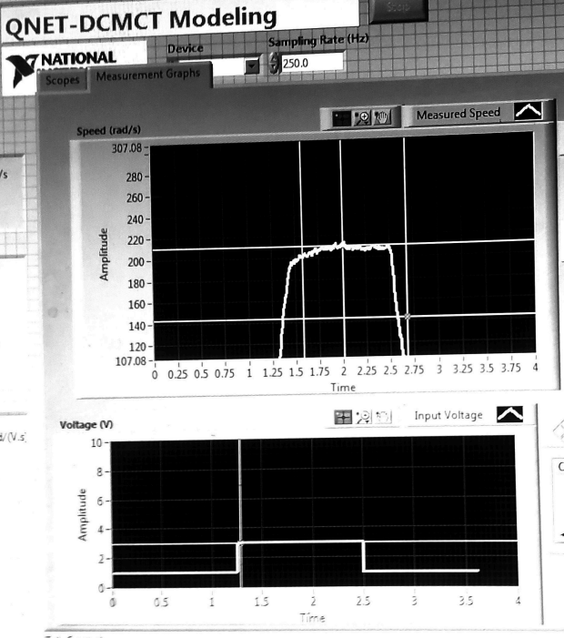

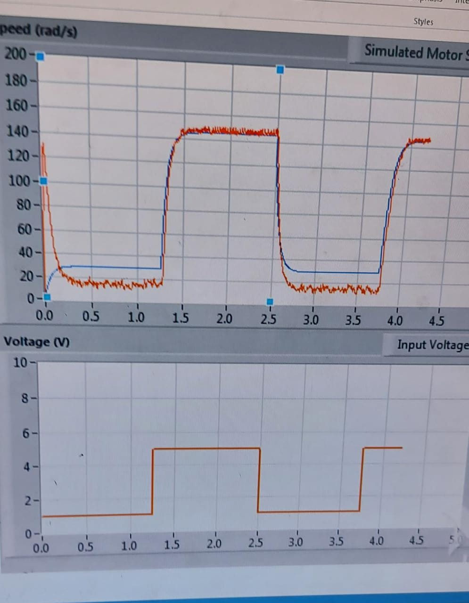

**QUESTION:**

**How well does your model represent the actual system? If they do not match, name one possible source of discrepancy.**

Ans: While my model may not be operating in accordance with the precise values of K and tau, the actual system was modeled by providing the system with those values.

**Application:**

By doing this experiment The system can be easily set up to control the position and speed of the motor.The system can be used to teach the basics of PID control in particular.

**Issues:**

No issue found while performing the lab.

**Conclusion:**

In this lab we learn that the experiment was carried out correctly, and the results of the observations for K and were recorded.